Learn to dance several easy line dances.  It is healthy and so much fun !  COME JOIN US FOR THIS  FUN FREE CLASS |  |  |  | 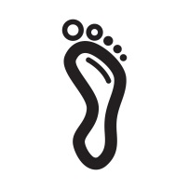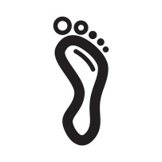
 |  |  | Line Dance Class  Wednesdays 1:30pm  Instructor: Linda Baker
 |  | River Oaks  Event Center  5300 Blackstone Dr.  River Oaks, Texas 76114  817-732-5885  www.riveroakscommunitycenter.com

